HTML PROJECT REPORT

Deadline: Tuesday December 5th 2014

PROJECT TEAM
Student No | Student Names
X14431668 | Shannon Bolton
X14479602 | Stacey Flood

** SS Airlines **

- OVERVIEW / INTRODUCTION

Motivation for the Project

Before we started working on our project we both decided that we wanted our website to be bright. And appealing to our customers eyes. We wanted to use as many images and as much colour as we could. This would hopefully make our airline company more recognisable to all our present and future customers. Our plan for our website was to include a homepage , an about page , a services/products page and a contact page. We decided on a colour scheme of blue and red for our website and we made a logo that was unique from any others out there. The requirements we were given for our website are as follows :
- A blue background.
- A logo in the top left hand corner.
- Navigation panel down the left hand side.
- At least one map.

Technical Approach

** This section should outline how you initially plan to approach project development, what the plans were for the concept and how they could evolve. **

STORYBOARD / WIREFRAME

Here we have our four wireframes. The first one is our home page , the second one is our about page , the third one is our contact page and our fourth one is the services/products page.

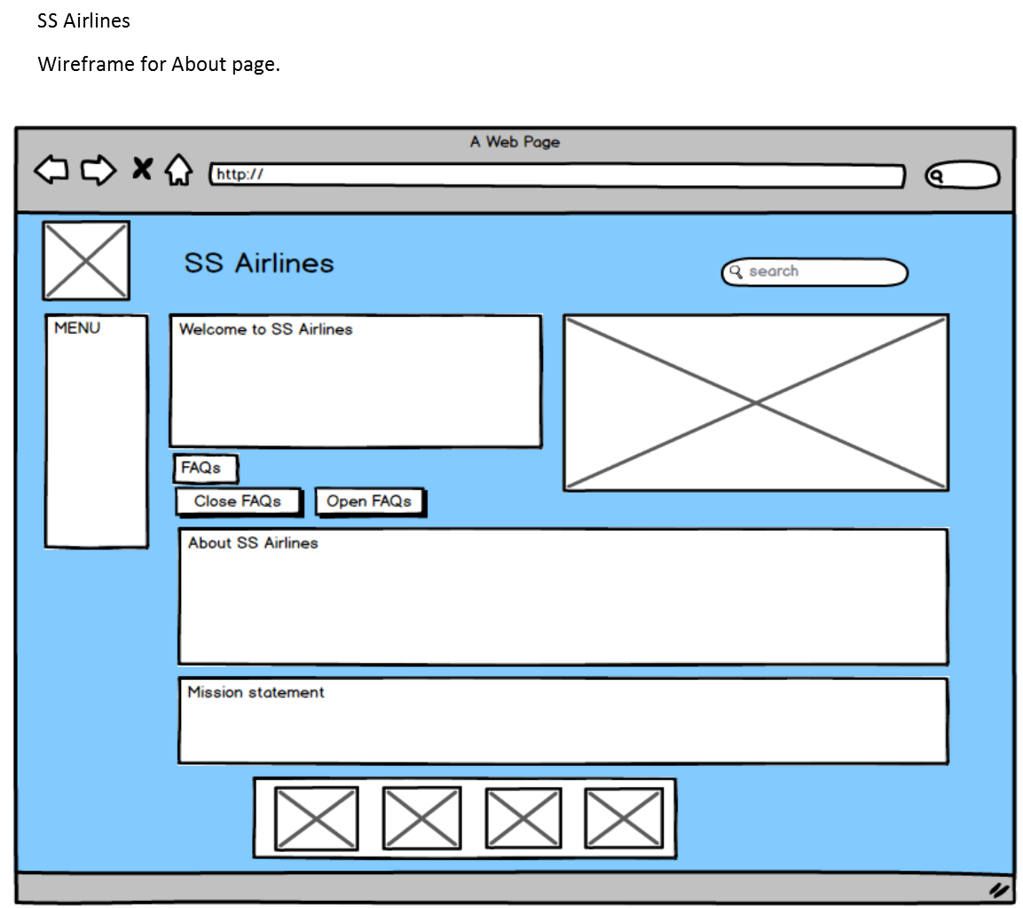
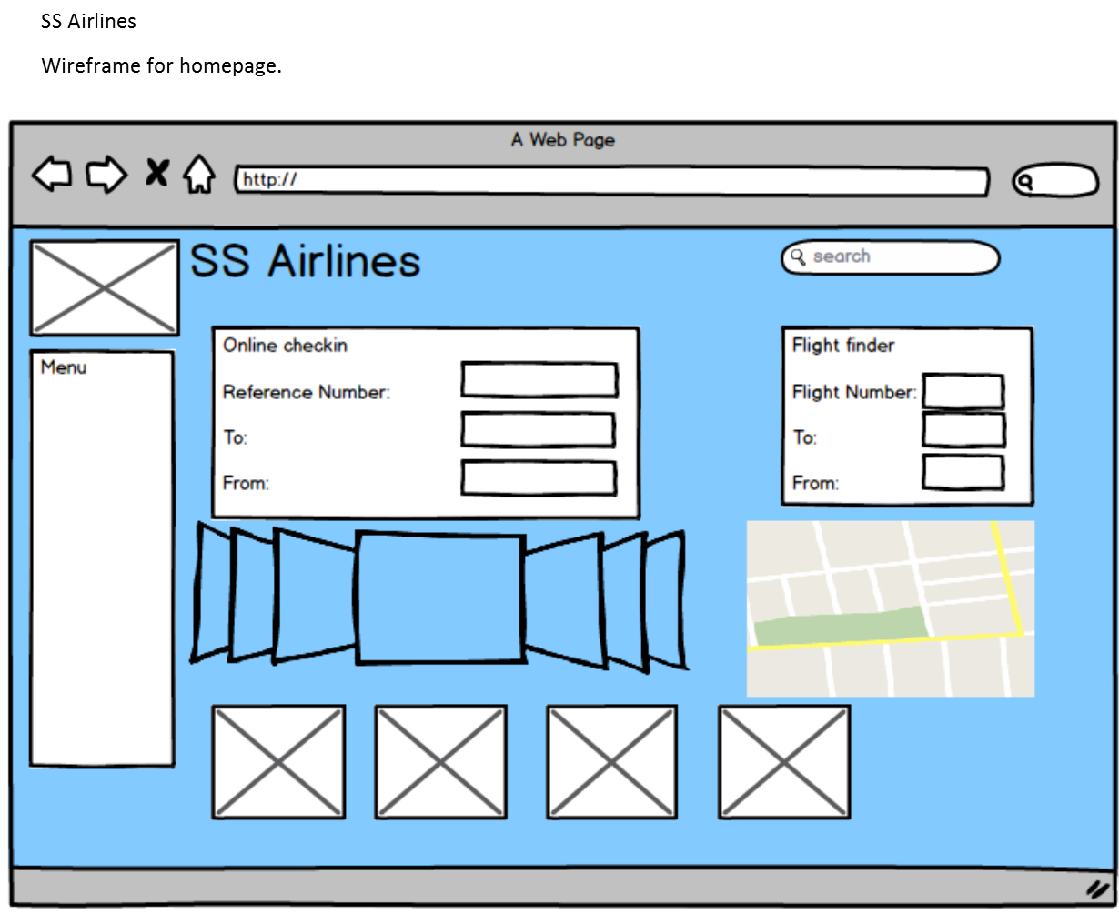
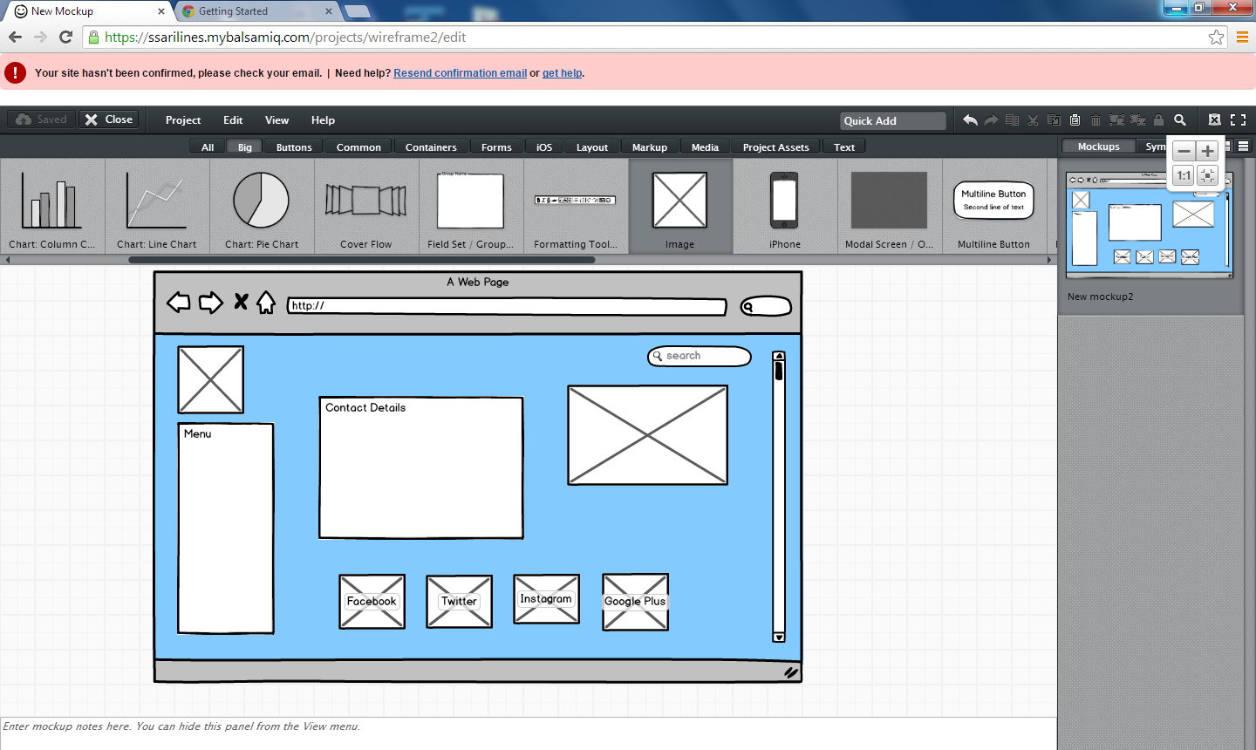

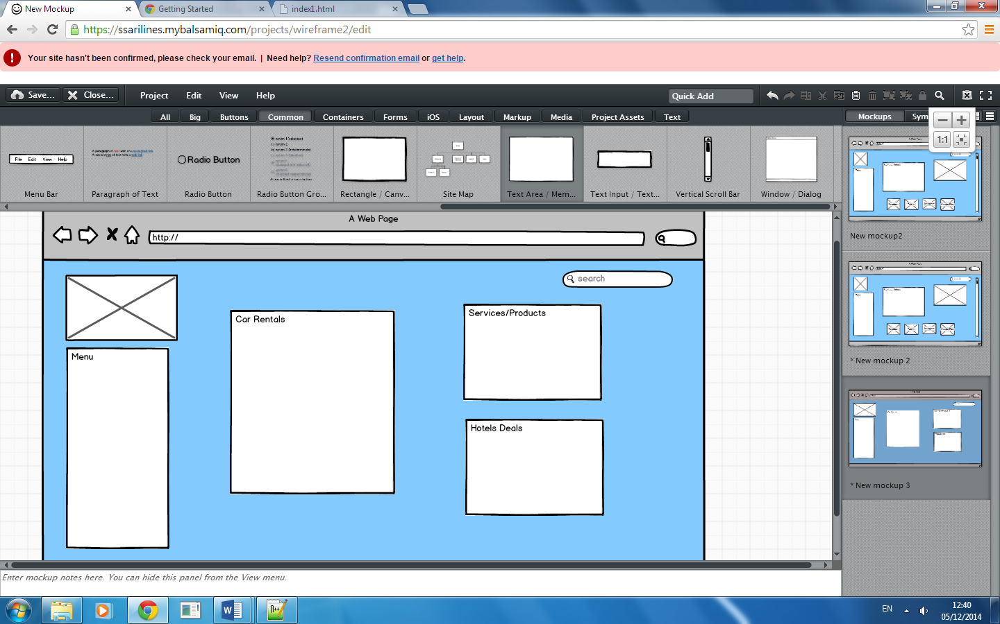
PRODUCTION LOG

** This section should outline how you went about developing your webpage, i.e. HTML, CSS, JavaScript. This should include development details, any technical details, such as errors or development issues and how you fixed these.
Please note: Make sure to include explanation (as well as comments in the HTML files) of any & all code that was taken from the web, or you will not receive marks for this third party code. **

Validation

** This section should look at validation of the website, were you able to validate the website, were there any errors and if so, how did you go about fixing them. Please include a screenshot of your validation report here **
Here are our validation sheets for the html files and the css files.We tried to fix these but some of them wouldn’t work for us.

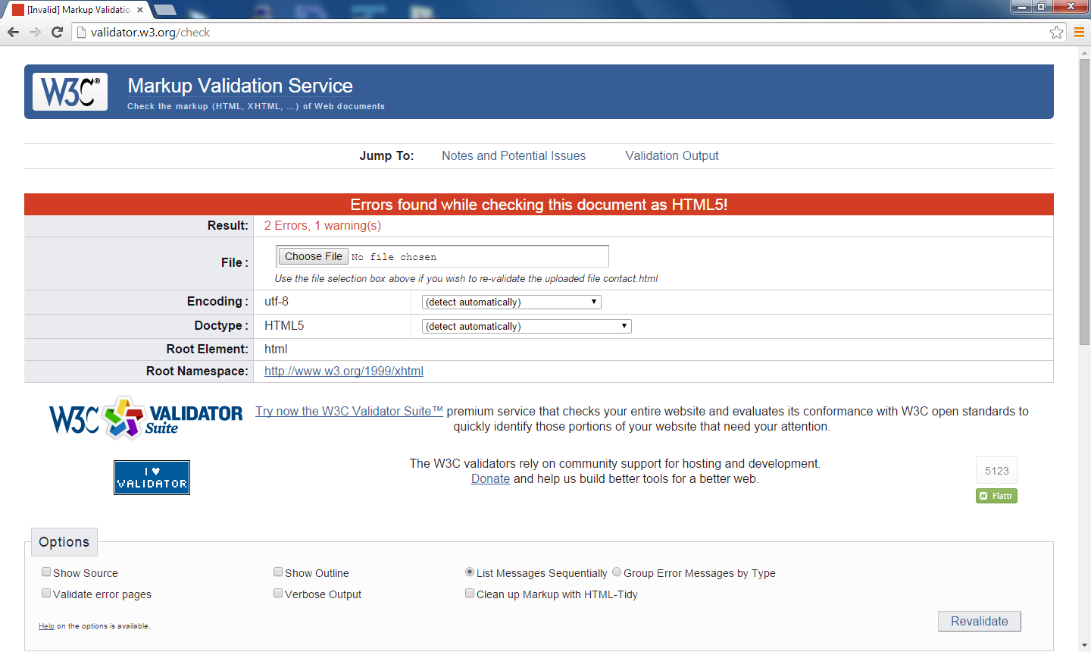

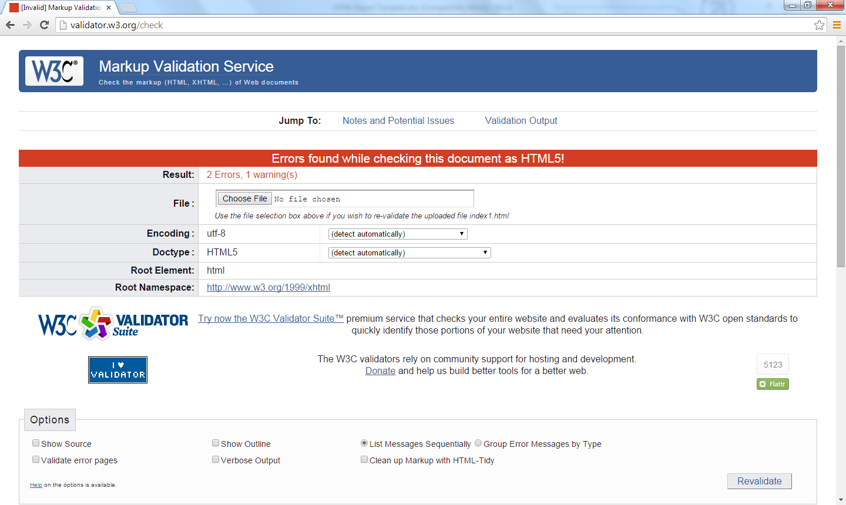

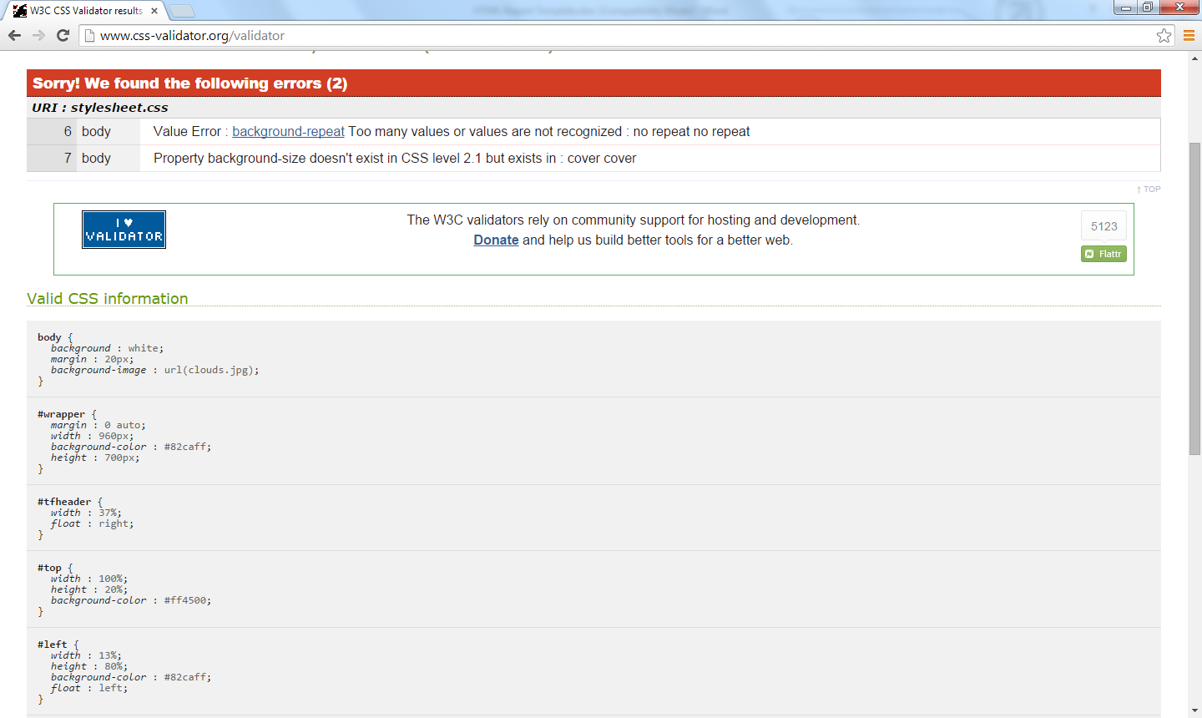

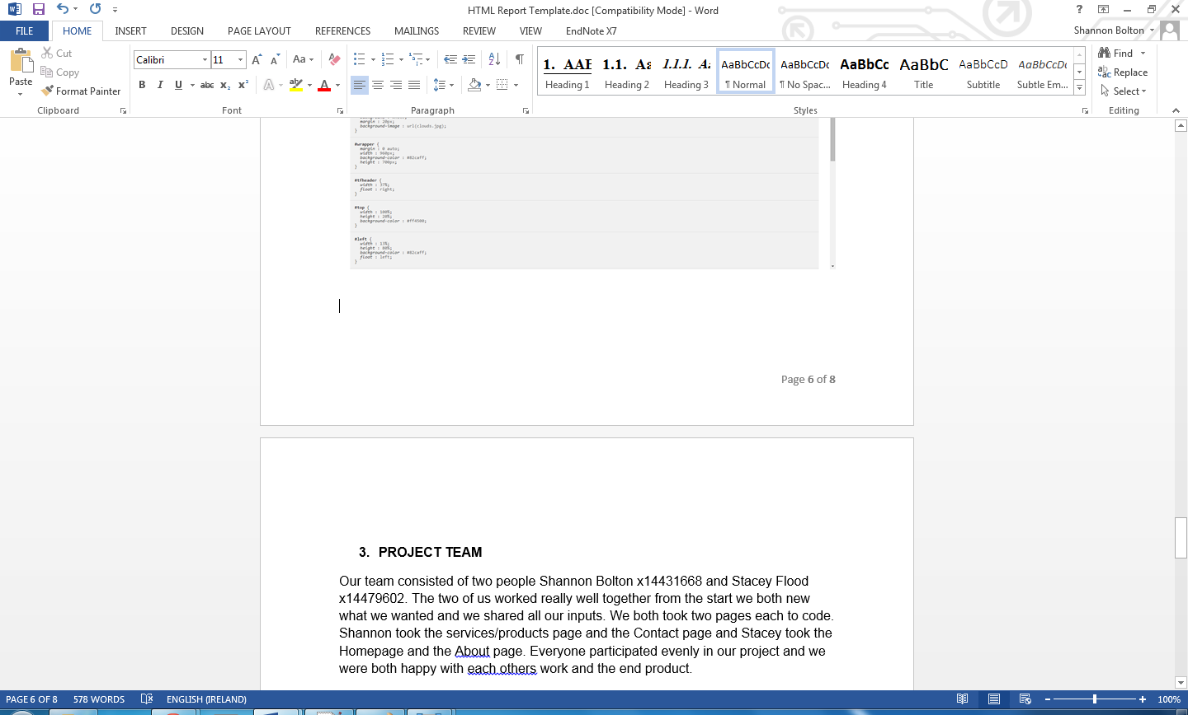

- PROJECT TEAM
Our team consisted of two people Shannon Bolton x14431668 and Stacey Flood x14479602. The two of us worked really well together from the start we both new what we wanted and we shared all our inputs. We both took two pages each to code. Shannon took the services/products page and the Contact page and Stacey took the Homepage and the About page. Everyone participated evenly in our project and we were both happy with each others work and the end product.

- CONCLUSION
When our project was finished I think we were both really happy with what we created. It took a lot of time but we both were prepared to put all of the efforts into it. I would not change anything about our website because I thought it was unique and it showed all the hard work that the two of us put into it. However if we had more time I think I would of added another page which would of contained information about lost baggage and having trouble with online check in etc.

- REFERENCES
** Make sure to include and third party resources / information / code used here.
Make sure to reference correctly as needed, i.e. Harvard Referencing. **

